**Expt. No. : 04 GROUP FUNCTIONS**

Expt no: 4

1. Create a table named SALES_22co61 and insert the data in the table.



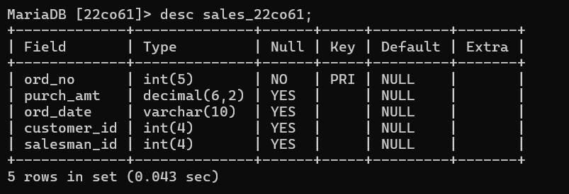

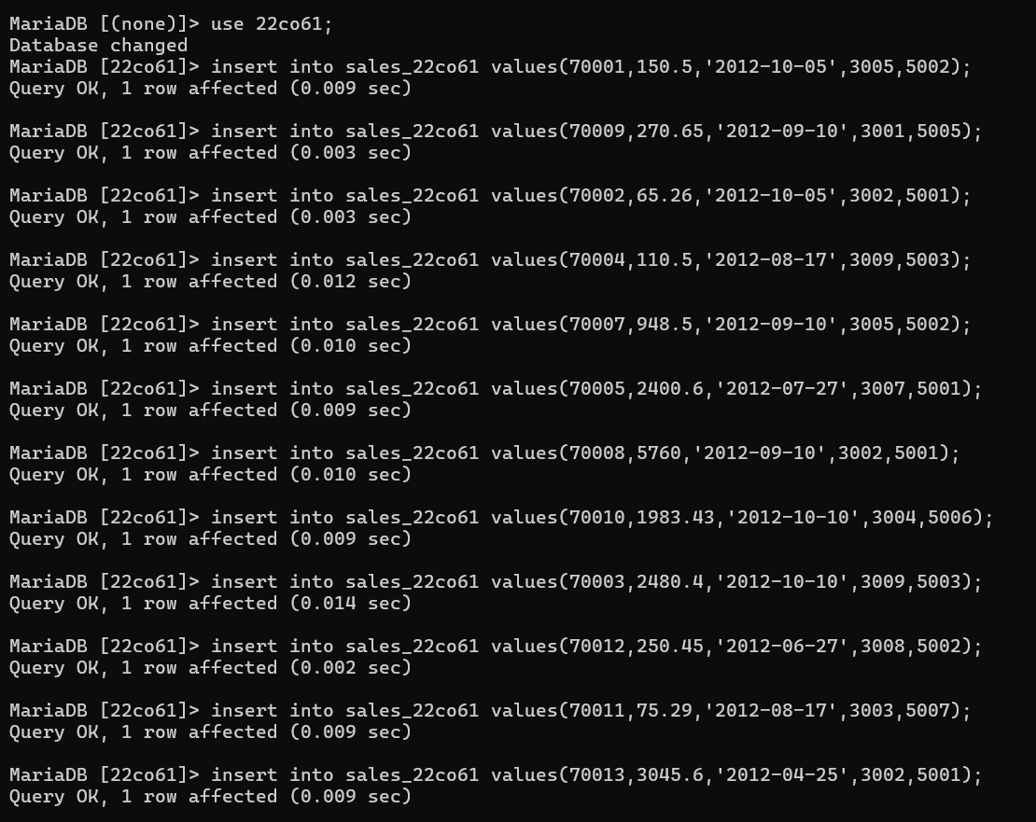

2. Display the contents of the SALES_22co61

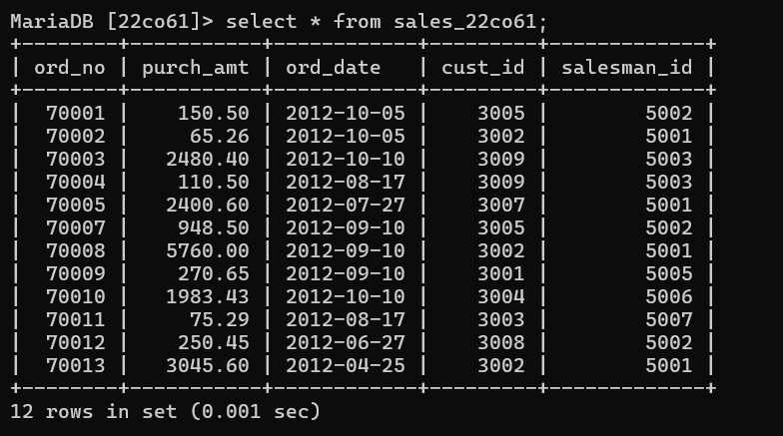

3. Write a SQL statement to find the total purchase amount for all orders.

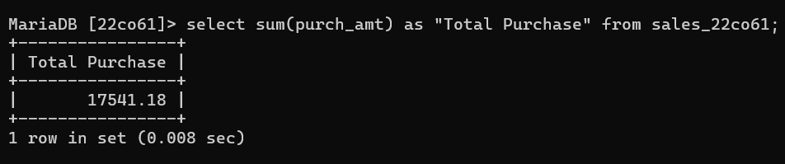

4. Write a SQL statement to find the average purchase amount of all orders.

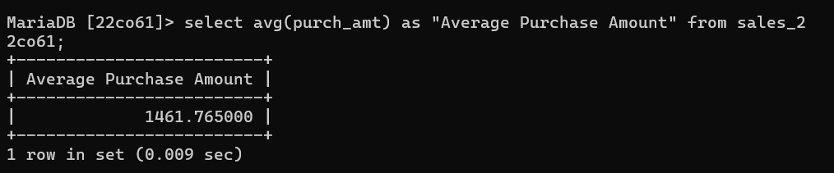

5. Write a SQL statement to find the distinct salesman from sales.

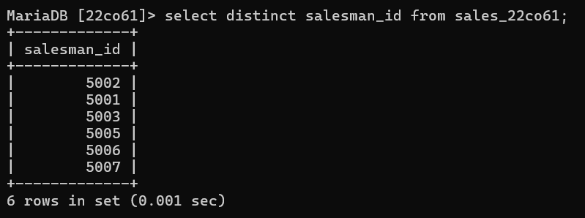

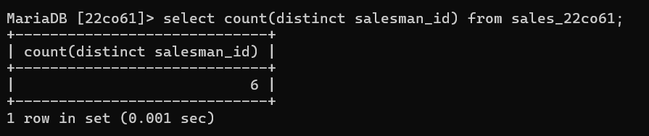

6. Write a SQL statement to get the maximum purchase amount of all the orders.

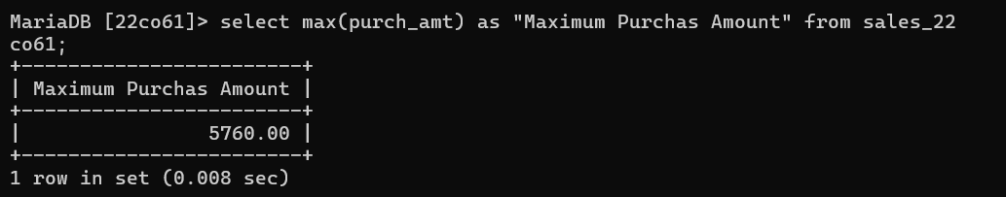

7. Write a SQL statement to get the minimum purchase amount of all the orders.

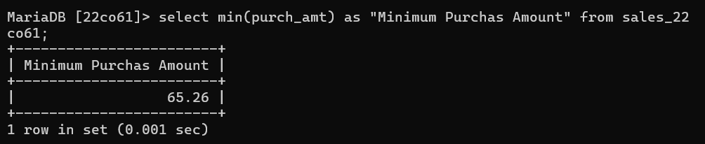

8. Find the highest purchase amount ordered by the each customer.

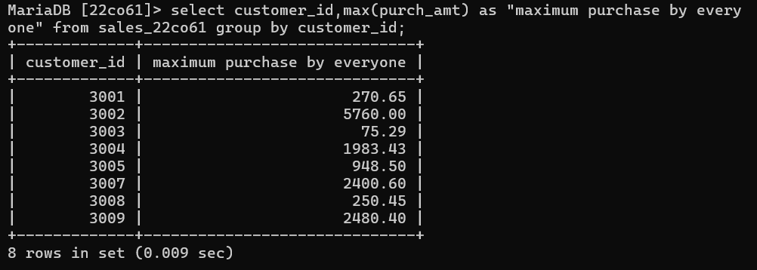

9. Write a SQL statement to find the highest purchase amount ordered by the each customer on a particular date with their ID, order date and highest purchase amount.

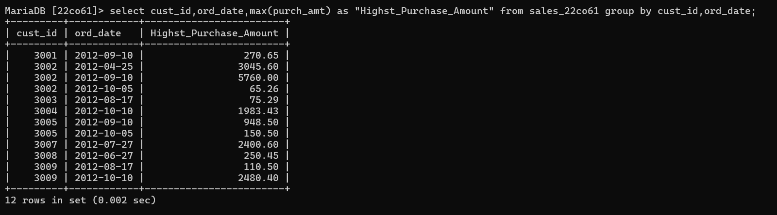

10. Write a SQL statement to find the highest purchase amount on a date 2012-08-17; for each salesman with their ID.

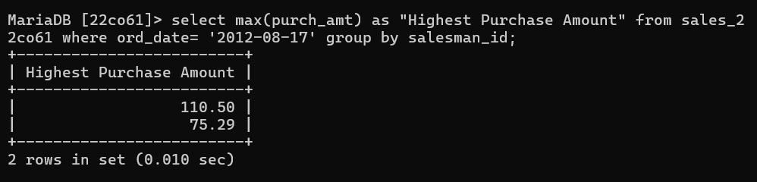

11. Write a SQL statement to find the highest purchase amount with their ID and order date, for only those customers who have highest purchase amount in a day is more than 2000.

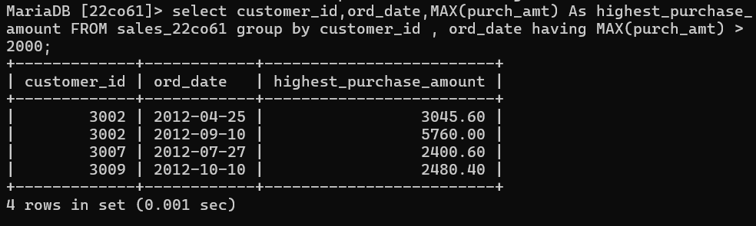

12. Write a SQL statement to find the highest purchase amount with their ID and order date, for those customers who have a higher purchase amount in a day is within the range 2000 and 6000.

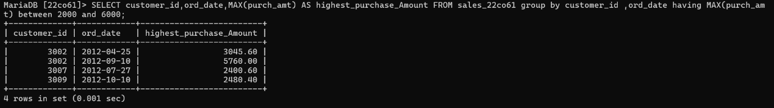

13. Write a SQL statement to find the highest purchase amount with their ID and order date, for only those customers who have a higher purchase amount in a day is within the list 2000, 3000, 5760 and 6000.

